EX1:
#define _CRT_SECURE_NO_WARNINGS
#include <stdio.h>
struct Sstudent {
char name[50];
int roll;
float marks;
};
int main() {
struct Sstudent s1;
printf("Enter information of students:\n");printf("\n");
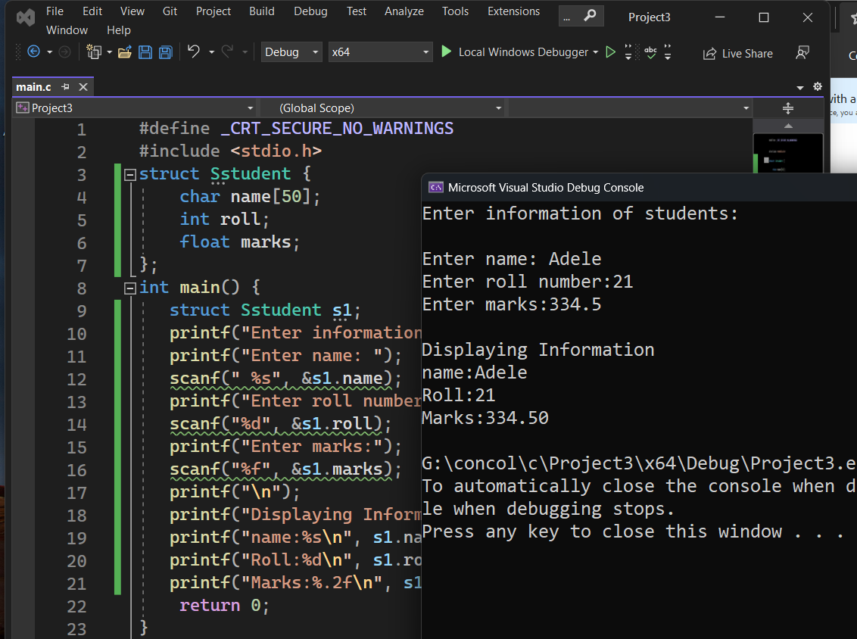
printf("Enter name: ");
scanf(" %s", &s1.name);
printf("Enter roll number:");
scanf("%d", &s1.roll);
printf("Enter marks:");
scanf("%f", &s1.marks);
printf("\n");
printf("Displaying Information\n");
printf("name:%s\n", s1.name);
printf("Roll:%d\n", s1.roll);
printf("Marks:%.2f\n", s1.marks);
return 0;
}

Ex2:
#define _CRT_SECURE_NO_WARNINGS
#include <stdio.h>
struct Distance {
int feet;
float inch;};
int main() {
struct Distance d1, d2, sum;
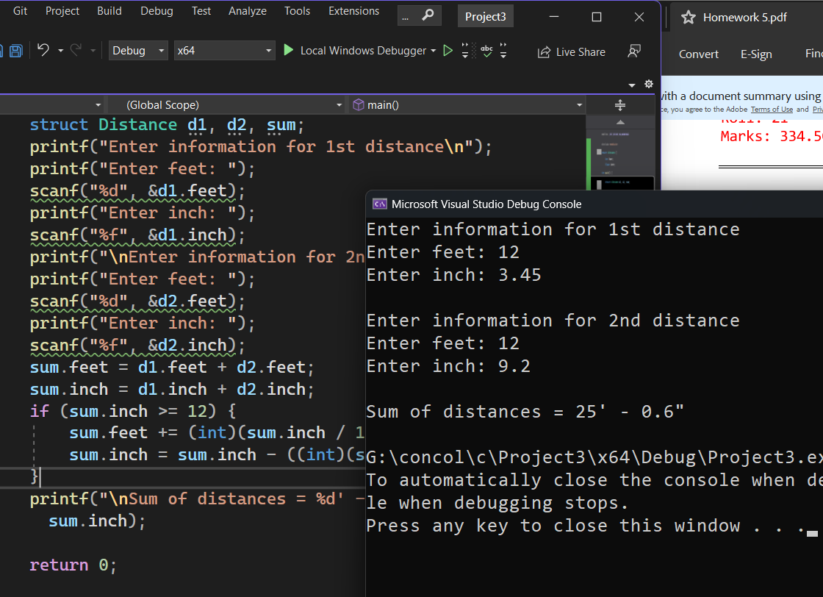
printf("Enter information for 1st distance\n");
printf("Enter feet: ");
scanf("%d", &d1.feet);
printf("Enter inch: ");
scanf("%f", &d1.inch);
printf("\nEnter information for 2nd distance\n");
printf("Enter feet: ");
scanf("%d", &d2.feet);
printf("Enter inch: ");
scanf("%f", &d2.inch);
sum.feet = d1.feet + d2.feet;
sum.inch = d1.inch + d2.inch;
if (sum.inch >= 12) {
sum.feet += (int)(sum.inch / 12);
sum.inch = sum.inch - ((int)(sum.inch / 12) * 12); }
printf("\nSum of distances = %d' - %.1f\"\n", sum.feet, sum.inch);
return 0;
}
Ex3:
#define _CRT_SECURE_NO_WARNINGS
#include <stdio.h>
struct SComplex_Nnmber {
float real;
float imaginary;
};
int main() {
struct SComplex_Nnmber d1, d2, sum;
printf("for 1st complex number\n");
printf("Enter real and imaginary respectively: ");
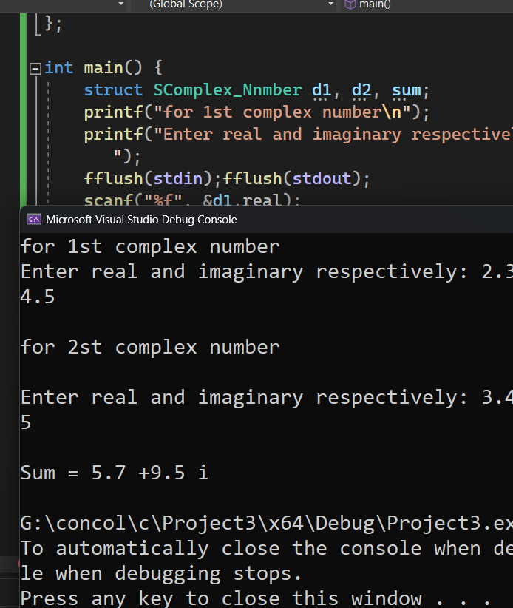
fflush(stdin);fflush(stdout);
scanf("%f", &d1.real);
scanf("%f", &d1.imaginary);
fflush(stdin);fflush(stdout);
printf("\nfor 2st complex number\n\n");
printf("Enter real and imaginary respectively: ");
fflush(stdin);fflush(stdout);
scanf("%f", &d2.real);
scanf("%f", &d2.imaginary);
sum.real = d1.real + d2.real;
sum.imaginary = d1.imaginary + d2.imaginary;
printf("\nSum = %.1f +%.1f i\n", sum.real, sum.imaginary);
return 0;
}

Ex4:
#define _CRT_SECURE_NO_WARNINGS
#include <stdio.h>
struct Sstudent {
char name[50];
int roll;
float marks;
};
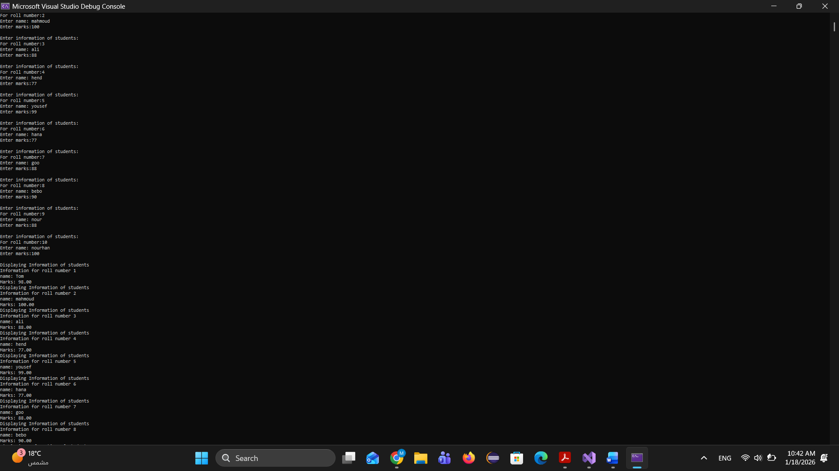
int main() {
struct Sstudent Sdtata[10];int i;
for (i = 0;i < 10;i++) {
printf("Enter information of students:\n");
printf("For roll number:%d\n",i+1);
Sdtata[i].roll = i + 1;
printf("Enter name: ");
scanf(" %s",&Sdtata[i].name);
printf("Enter marks:");
scanf("%f", &Sdtata[i].marks);
printf("\n");}
for (i = 0; i < 10; i++)
{ printf("Displaying Information of students\n");
printf("Information for roll number %d\n", i+1);
printf("name: %s\n", Sdtata[i].name);
printf("Marks: %.2f\n", Sdtata[i].marks);}
return 0;
}
Ex5:
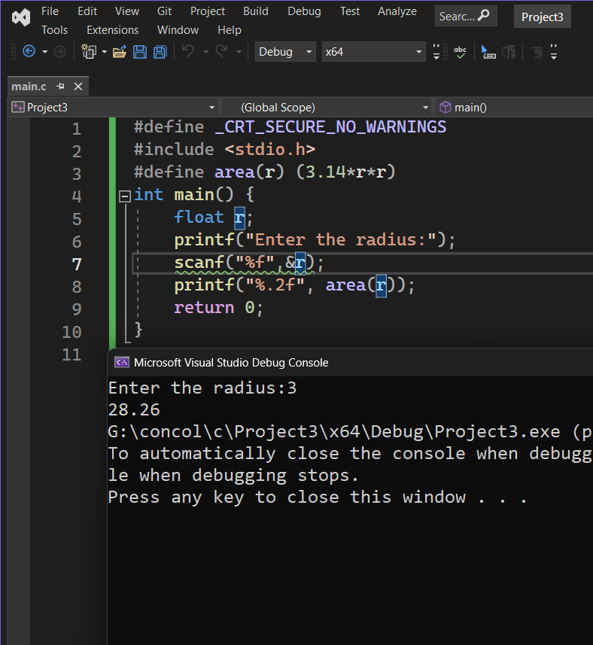
#define _CRT_SECURE_NO_WARNINGS
#include <stdio.h>
#define area(r) (3.14*r*r)
int main() {
float r;
printf("Enter the radius:");
scanf("%f",&r);
printf("%.2f", area(r));
return 0;
}

Ex6:
size of union=32
size of structure=40
here the structure don’t need padding because the big element % each element=0 ;

